Prelab for Lab7

Xiaoyu Zhou, 1004081147

**Part I**

9. Simulation

10. Instantiate the ram32x4 module into a top-level Verilog modul

module top (SW, KEY, HEX0, HEX2, HEX4, HEX5);

input [9:0] SW;

input [3:0] KEY;

output [6:0] HEX0;

output [6:0] HEX2;

output [6:0] HEX4;

output [6:0] HEX5;

wire out;

kk u1(

.address(SW[8:4]),

.clock(KEY[0]),

.data(SW[3:0]),

.wren(SW[9]),

.q(out)

);

hex dataa(

.in2(SW[3]),

.in3(SW[2]),

.in4(SW[1]),

.in5(SW[0]),

.o2(HEX2[0]),

.o3(HEX2[1]),

.o4(HEX2[2]),

.o5(HEX2[3]),

.o6(HEX2[4]),

.o7(HEX2[5]),

.o8(HEX2[6])

);

hex outtt(

.in2(out[3]),

.in3(out[2]),

.in4(out[1]),

.in5(out[0]),

.o2(HEX0[0]),

.o3(HEX0[1]),

.o4(HEX0[2]),

.o5(HEX0[3]),

.o6(HEX0[4]),

.o7(HEX0[5]),

.o8(HEX0[6])

);

hex addd1(

.in2(SW[7]),

.in3(SW[6]),

.in4(SW[5]),

.in5(SW[4]),

.o2(HEX4[0]),

.o3(HEX4[1]),

.o4(HEX4[2]),

.o5(HEX4[3]),

.o6(HEX4[4]),

.o7(HEX4[5]),

.o8(HEX4[6])

);

hex addd2(

.in2(0),

.in3(0),

.in4(0),

.in5(SW[8]),

.o2(HEX5[0]),

.o3(HEX5[1]),

.o4(HEX5[2]),

.o5(HEX5[3]),

.o6(HEX5[4]),

.o7(HEX5[5]),

.o8(HEX5[6])

.o7(HEX5[5]),

.o8(HEX5[6])

);

endmodule

// synopsys translate_off

`timescale 1 ps / 1 ps

// synopsys translate_on

module kk (

address,

clock,

data,

wren,

q);

input [4:0] address;

input clock;

input [3:0] data;

input wren;

output [3:0] q;

`ifndef ALTERA_RESERVED_QIS

// synopsys translate_off

`endif

tri1 clock;

`ifndef ALTERA_RESERVED_QIS

// synopsys translate_on

`endif

wire [3:0] sub_wire0;

wire [3:0] q = sub_wire0[3:0];

altsyncram altsyncram_component (

.address_a (address),

.clock0 (clock),

.data_a (data),

.wren_a (wren),

.q_a (sub_wire0),

.aclr0 (1'b0),

.aclr1 (1'b0),

.address_b (1'b1),

.addressstall_a (1'b0),

.addressstall_b (1'b0),

.byteena_a (1'b1),

.byteena_b (1'b1),

.clock1 (1'b1),

.clocken0 (1'b1),

.clocken1 (1'b1),

.clocken2 (1'b1),

.clocken3 (1'b1),

.data_b (1'b1),

.eccstatus (),

.q_b (),

.rden_a (1'b1),

.rden_b (1'b1),

.wren_b (1'b0));

defparam

altsyncram_component.clock_enable_input_a = "BYPASS",

altsyncram_component.clock_enable_output_a = "BYPASS",

altsyncram_component.intended_device_family = "Cyclone V",

altsyncram_component.lpm_hint = "ENABLE_RUNTIME_MOD=NO",

altsyncram_component.lpm_type = "altsyncram",

altsyncram_component.numwords_a = 32,

altsyncram_component.operation_mode = "SINGLE_PORT",

altsyncram_component.outdata_aclr_a = "NONE",

altsyncram_component.outdata_reg_a = "CLOCK0",

altsyncram_component.power_up_uninitialized = "FALSE",

altsyncram_component.read_during_write_mode_port_a = "NEW_DATA_NO_NBE_READ",

altsyncram_component.widthad_a = 5,

altsyncram_component.width_a = 4,

altsyncram_component.width_byteena_a = 1;

endmodule

module hex(in2, in3, in4, in5, o2, o3, o4, o5, o6, o7, o8);

input in2;

input in3;

input in4;

input in5;

output o2;

output o3;

output o4;

output o5;

output o6;

output o7;

output o8;

hex0 u1(

.c3(in2),

.c2(in3),

.c1(in4),

.c0(in5),

.out1(o2)

);

hex1 u2(

.c3(in2),

.c2(in3),

.c1(in4),

.c0(in5),

.out2(o3)

);

hex2 u3(

.c3(in2),

.c2(in3),

.c1(in4),

.c0(in5),

.out3(o4)

);

hex3 u4(

.c3(in2),

.c2(in3),

.c1(in4),

.c0(in5),

.out4(o5)

);

hex4 u5(

.c3(in2),

.c2(in3),

.c1(in4),

.c0(in5),

.out5(o6)

);

hex5 u6(

.c3(in2),

.c2(in3),

.c1(in4),

.c0(in5),

.out6(o7)

);

hex6 u7(

.c3(in2),

.c2(in3),

.c1(in4),

.c0(in5),

.out7(o8)

);

endmodule

module hex0(c3, c2, c1, c0, out1);

input c3; //selected when s is 0

input c2; //selected when s is 1

input c1; //select signal

input c0;

output out1; //output

assign out1 = ~c3 & c2 & ~c1 & ~c0 | c3 & c2 & ~c1 & c0 | c3 & ~c2 & c1 & c0 | ~c3 & ~c2 & ~c1 & c0;

endmodule

module hex1(c3, c2, c1, c0, out2);

input c3; //selected when s is 0

input c2; //selected when s is 1

input c1; //select signal

input c0;

output out2; //output

assign out2 = c2 & c1 & ~c0 | c3 & c1 & c0 | ~c3 & c2 & ~c1 & c0 | c3 & c2 & ~c0;

endmodule

module hex2(c3, c2, c1, c0, out3);

input c3; //selected when s is 0

input c2; //selected when s is 1

input c1; //select signal

input c0;

output out3; //output

assign out3 = ~c3 & ~c2 & c1 & ~c0 | c3 & c2 & c1 | c3 & c2 & ~c0;

endmodule

module hex3(c3, c2, c1, c0, out4);

input c3; //selected when s is 0

input c2; //selected when s is 1

input c1; //select signal

input c0;

output out4; //output

assign out4 = ~c3 & c2 & ~c1 & ~c0 | ~c2 & ~c1 & c0 | c2 & c1 & c0 | c3 & ~c2 & c1 & ~c0;

endmodule

module hex4(c3, c2, c1, c0, out5);

input c3; //selected when s is 0

input c2; //selected when s is 1

input c1; //select signal

input c0;

output out5; //output

assign out5 = ~c3 & c2 & ~c1 | ~c2 & ~c1 & c0 | ~c3 & c0;

endmodule

module hex5(c3, c2, c1, c0, out6);

input c3; //selected when s is 0

input c2; //selected when s is 1

input c1; //select signal

input c0;

output out6; //output

assign out6 = ~c3 & ~c2 & c0 | ~c3 & ~c2 & c1 | ~c3 & c1 & c0 | c3 & c2 & ~c1 & c0;

endmodule

module hex6(c3, c2, c1, c0, out7);

input c3; //selected when s is 0

input c2; //selected when s is 1

input c1; //select signal

input c0;

output out7; //output

assign out7 = ~c3 & ~c2 & ~c1 | c3 & c2 & ~c1 & ~c0 | ~c3 & c2 & c1 & c0;

endmodule

11. Schematic.

**Part II**

1. Verilog:

module datapath(clk, temp_x, temp_y, temp_c, reset_n, go, color_in, position, x_out, y_out, color_out);

input clk, temp_x, temp_y, temp_c, reset_n, go;

input [2:0] color_in;

input [6:0] position;

output [7:0] x_out;

output [6:0] y_out;

output [2:0] color_out;

reg [2:0] count_x, count_y;

reg [7:0] real_x;

reg [6:0] real_y;

reg [2:0] color;

// registors for x, y and color

always @(posedge clk) begin

if (!reset_n) begin

real_x <= 8'b0;

real_y <= 7'b0;

color <= 3'b0;

end

else begin

if (temp_x)

real_x <= {1'b0, position};

if (temp_y)

real_y <= position;

if (temp_c)

color <= color_in;

end

end

// counter for x

always @(posedge clk) begin

if (!reset_n)

count_x <= 2'b00;

else if (go) begin

if (count_x == 2'b11)

count_x <= 2'b00;

else begin

count_x <= count_x + 1'b1;

end

end

end

// counter for y

always @(posedge clk) begin

if (!reset_n)

count_y <= 2'b00;

else if (go && (count_x == 2'b11)) begin

if (count_y != 2'b11)

count_y <= count_y + 1'b1;

else

count_y <= 2'b00;

end

end

assign x_out = real_x + count_x;

assign y_out = real_y + count_y;

assign color_out = color;

endmodule

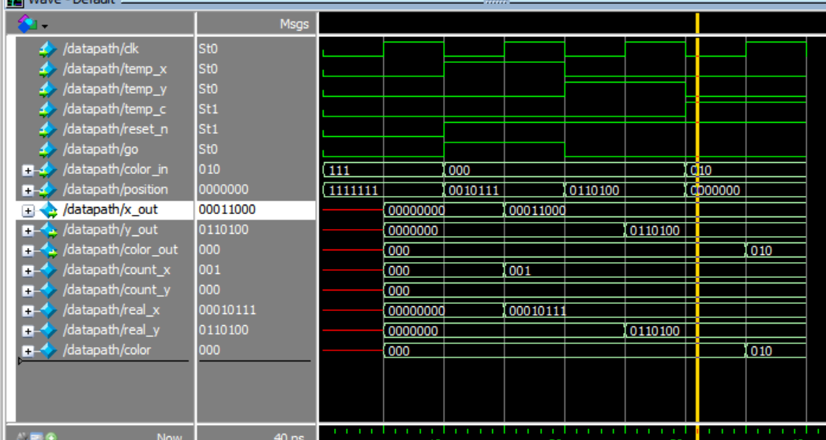Simulation:

State Diagram

State Table

Verilog

module control(clk, reset_n, ld, draw, temp_x, temp_y, temp_c, go);

input clk, reset_n, ld, draw;

output reg temp_x, temp_y, temp_c, go;

reg [2:0] current_state, next_state;

localparam

Load_x = 3'd0,

Load_x_wait = 3'd1,

Load_y = 3'd2,

Load_y_wait = 3'd3,

Load_c = 3'd4,

Load_c_wait = 3'd5,

Draw = 3'd6;

always @(*) begin

case (current_state)

Load_x: next_state = ld ? Load_x_wait : Load_x;

Load_x_wait: next_state = ld ? Load_x_wait : Load_y;

Load_y: next_state = ld ? Load_y_wait : Load_y;

Load_y_wait: next_state = ld ? Load_y_wait : Load_c;

Load_c: next_state = draw ? Load_c_wait : Load_c;

Load_c_wait: next_state = draw ? Load_c_wait : Draw;

Draw: next_state = ld ? Load_x : Draw;

endcase

end

always @(*) begin

temp_x = 1'b0;

temp_y = 1'b0;

temp_c = 1'b0;

go = 1'b0;

case (current_state)

Load_x: begin

temp_x = 1;

end

Load_y: begin

temp_y = 1;

end

Load_c: begin

temp_c = 1;

end

Draw: begin

go = 1;

end

endcase

end

always @(posedge clk) begin

if (!reset_n)

current_state <= Load_x;

else

current_state <= next_state;

end

endmodule

Simulation

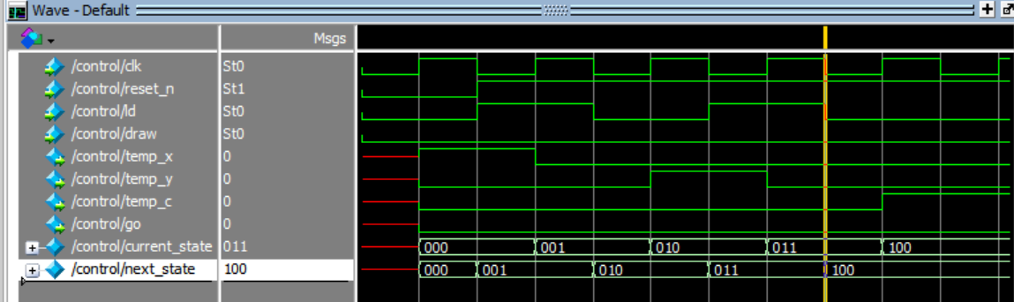

1. 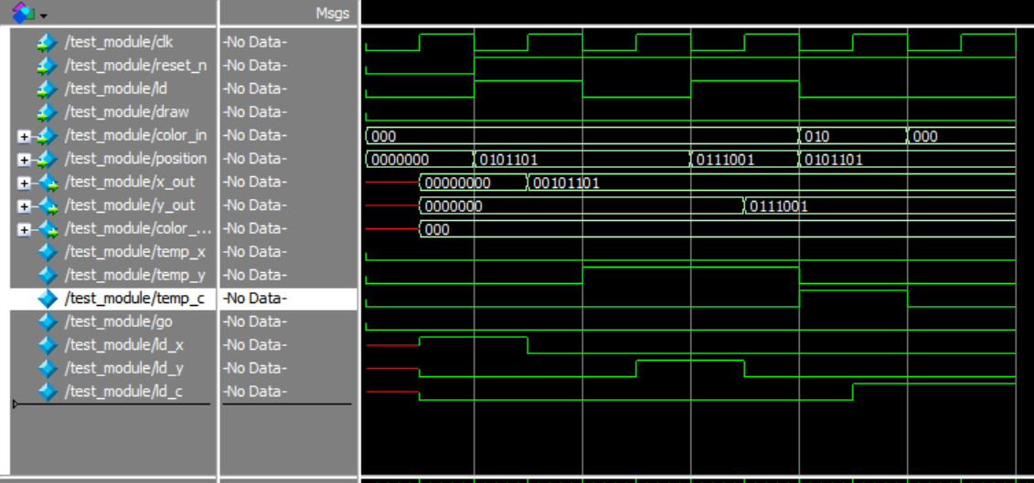Simulation

**Part III**

Verilog

module datapath(enable,clock,ld_c,colour,reset_n,X,Y,colour_out);

input enable,clock,reset_n,ld_c;

input [2:0] colour;

output[7:0] X,Y;

output[2:0] colour_out;

wire enable_fc;

wire enable_xy;

wire[3:0] c1;

wire signal_x,signal_y;

wire[7:0] x_in,y_in;

wire[2:0] colour_1;

x_counter x_c(

.x_in(x_in),

.clock(clock),

.reset_n(reset_n),

.enable(enable_xy),

.x_out(x_in)

);

y_counter y_c(

.y_in(y_in),

.clock(clock),

.reset_n(reset_n),

.enable(enable_xy),

.y_out(y_in)

);

delay_counter dc1(

.clock(clock),

.reset_n(reset_n),

.enable(enable),

.enable_fc(enable_fc)

);

frame_counter fc2(

.clock(clock),

.reset_n(reset_n),

.enable(enable_fc),

.enable_xy(enable_xy),

.colour_1(colour_1),

.colour(colour)

);

draw dr1(x_in,y_in,colour_1,ld_c,clock,reset_n,enable,X,Y,colour_out);

endmodule

Simulation

2.

State Diagram

Verilog

module control(clock,reset_n,go,enable,ld_c,plot);

input clock,reset_n,go;

output reg enable,ld_c,plot;

reg [3:0] current_state, next_state;

localparam S_LOAD_C = 4'd0,

S_LOAD_C_WAIT = 4'd1,

S_CYCLE_0 = 4'd2;

always@(*)

begin: state_table

case (current_state)

S_LOAD_C: next_state = go ? S_LOAD_C_WAIT : S_LOAD_C;

S_LOAD_C_WAIT: next_state = go ? S_LOAD_C_WAIT : S_CYCLE_0;

S_CYCLE_0: next_state = S_CYCLE_0;

default: next_state = S_LOAD_C;

endcase

end

always@(*)

begin: enable_signals

// By default make all our signals 0

ld_c = 1'b0;

enable = 1'b0;

plot = 1'b0;

case(current_state)

S_LOAD_C:begin

end

S_CYCLE_0:begin

ld_c = 1'b1;

enable = 1'b1;

plot = 1'b1;

end

endcase

end

always@(posedge clock)

begin: state_FFs

if(!reset_n)

current_state <= S_LOAD_C;

else

current_state <= next_state;

end

endmodule

Simulation

